**LockedMe – Virtual Key for Repositories**

This document contains sections for:

* Sprint planning and Task completion
* Core concepts used in project
* Flow of the Application.
* Demonstrating the product capabilities, appearance, and user interactions.
* Unique Selling Points of the Application
* Conclusions

The project is developed by Ritesh Kumar Dwivedi.

## Sprints planning and Task completion

The project is planned to be completed in 1 sprint. Tasks assumed to be completed in the sprint are:

* Creating the flow of the application
* Initializing git repository to track changes as development progresses.
* Writing the Java program to fulfill the requirements of the project.
* Testing the Java program with different kinds of User input
* Pushing code to GitHub.
* Creating this specification document highlighting application capabilities, appearance, and user interactions.

## Core concepts used in project

Collections framework, File Handling, Sorting, Flow Control, Recursion, Exception Handling, Streams API

## Flow of the Application

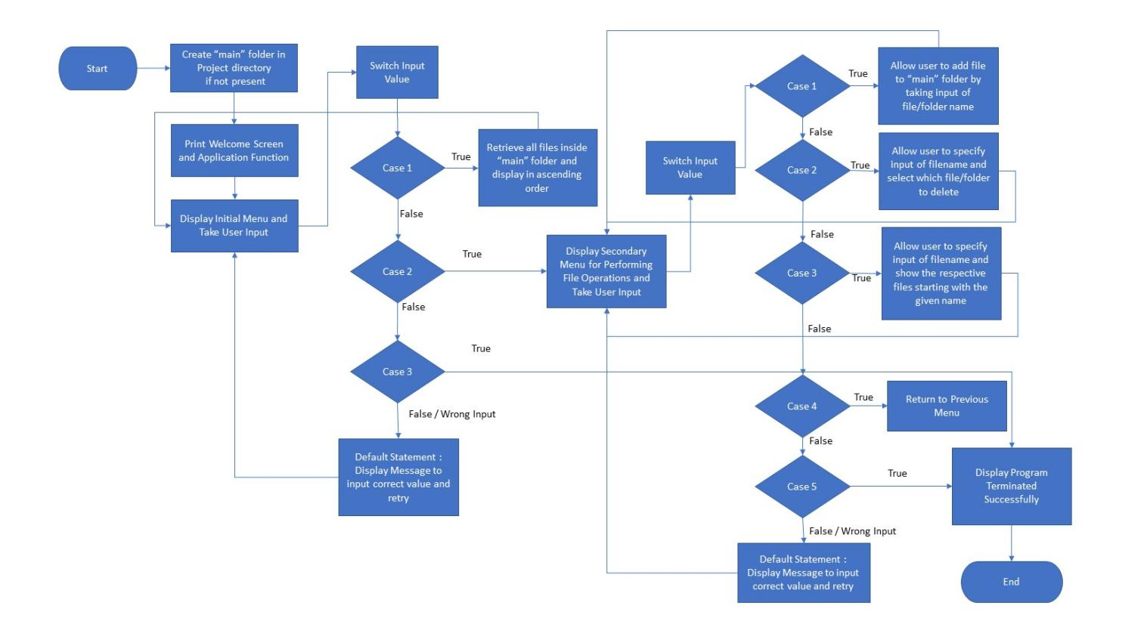

## Demonstrating the product capabilities, appearance, and user interactions

To demonstrate the product capabilities, below are the sub-sections configured to highlight appearance and user interactions for the project:

1. Creating the project in Eclipse
2. Writing a program in Java for the entry point of the application (**LockedMeMain.java**)
3. Writing a program in Java to display Menu options available for the user (**MenuOptions.java**)
4. Writing a program in Java to handle Menu options selected by user (**HandleOptions.java**)
5. Writing a program in Java to perform the File operations as specified by user (**FileOperations.java**)
6. Pushing the code to GitHub repository

## Writing a program in Java for the entry point of the application (**LockedMeMain.java**)

**package** com.lockedme;

**public** **class** LockedMeMain {

**public** **static** **void** main(String[] args) {

// Create "main" folder if not present in current folder structure

FileOperations.*createMainFolderIfNotPresent*("main");

MenuOptions.*printWelcomeScreen*("LockedMe", "Sitansu Subudhi");

HandleOptions.*handleWelcomeScreenInput*();

}

}

## **Step 3:** Writing a program in Java to display Menu options available for the user (**MenuOptions.java**)

* Select your project and go to File -> New -> Class.
* Enter **MenuOptions** in class name and click on “Finish.”
* **MenuOptions** consists methods for -:
  1. Displaying Welcome Screen
  2. Displaying Initial Menu
  3. Displaying Secondary Menu for File Operations available

**Step 3.1:** Writing method to display Welcome Screen

**public** **static** **void** printWelcomeScreen(String appName, String developerName) {

String companyDetails = String.*format*("*****************************************************\n"

+ "** Welcome to %s.com. \n" + "** This application was developed by %s.\n"

+ "*****************************************************\n", appName, developerName);

String appFunction = "You can use this application to :-\n"

+ "• Retrieve all file names in the \"main\" folder\n"

+ "• Search, add, or delete files in \"main\" folder.\n"

+ "\n**Please be careful to ensure the correct filename is provided for searching or deleting files.**\n";

System.***out***.println(companyDetails);

System.***out***.println(appFunction);

}

**Output:**

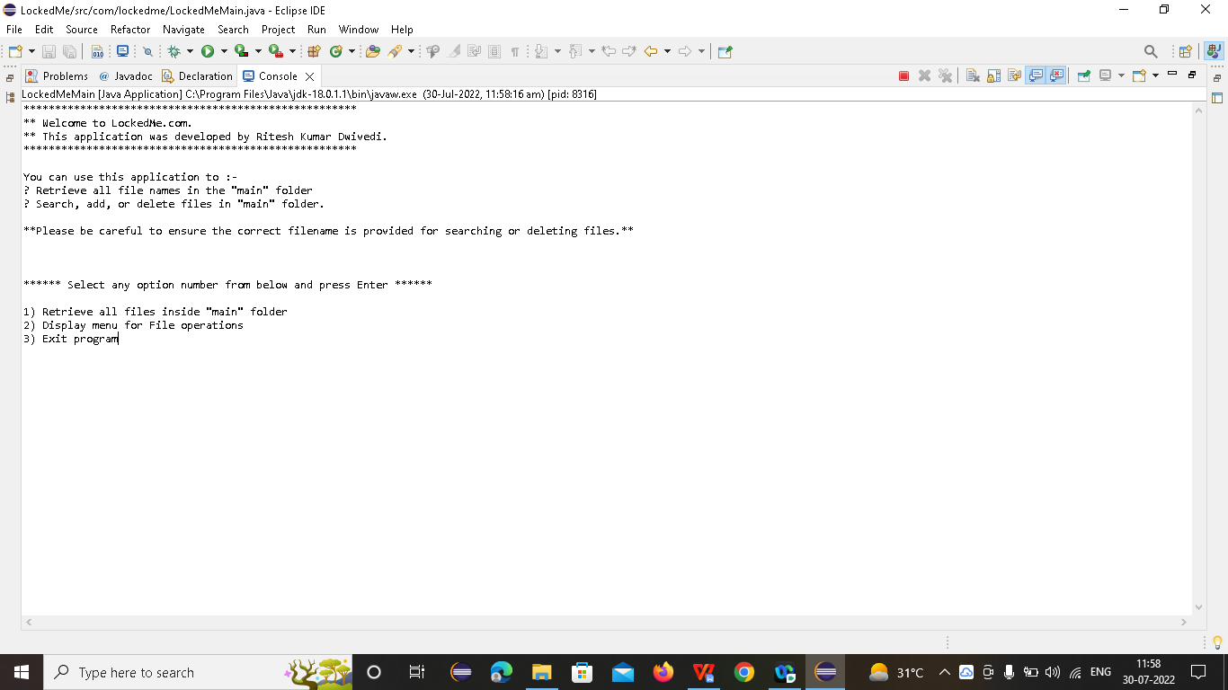

**Step 3.2:** Writing method to display Initial Menu

**public** **static** **void** displayMenu() {

String menu = "\n\n****** Select any option number from below and press Enter ******\n\n"

+ "1) Retrieve all files inside \"main\" folder\n" + "2) Display menu for File operations\n"

+ "3) Exit program\n";

System.***out***.println(menu);

}

**Output:**

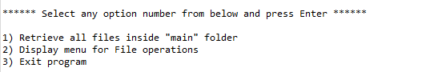

**Step 3.3:** Writing method to display Secondary Menu for File Operations

**public** **static** **void** displayFileMenuOptions() {

String fileMenu = "\n\n****** Select any option number from below and press Enter ******\n\n"

+ "1) Add a file to \"main\" folder\n" + "2) Delete a file from \"main\" folder\n"

+ "3) Search for a file from \"main\" folder\n" + "4) Show Previous Menu\n" + "5) Exit program\n";

System.***out***.println(fileMenu);

}

**Output:**

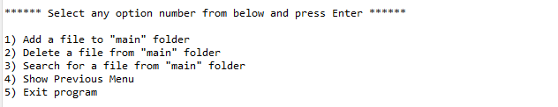

## **Step 4:** Writing a program in Java to handle Menu options selected by user (**HandleOptions.java**)

* Select your project and go to File -> New -> Class.
* Enter **HandleOptions** in class name and click on “Finish.”
* **HandleOptions** consists methods for -:
  1. Handling input selected by user in initial Menu
  2. Handling input selected by user in secondary Menu for File Operations

**Step 4.1:** Writing method to handle user input in initial Menu

**public** **static** **void** handleWelcomeScreenInput() {

**boolean** running = **true**;

Scanner sc = **new** Scanner(System.***in***);

**do** {

**try** {

MenuOptions.*displayMenu*();

**int** input = sc.nextInt();

**switch** (input) {

**case** 1:

FileOperations.*displayAllFiles*("main");

**break**;

**case** 2:

HandleOptions.*handleFileMenuOptions*();

**break**;

**case** 3:

System.***out***.println("Program exited successfully.");

running = **false**;

sc.close();

System.*exit*(0);

**break**;

**default**:

System.***out***.println("Please select a valid option from above.");

}

} **catch** (Exception e) {

System.***out***.println(e.getClass().getName());

*handleWelcomeScreenInput*();

}

} **while** (running == **true**);

}

**Output:**

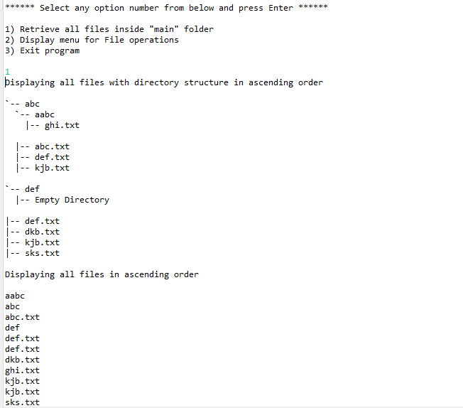

**Step 4.2:** Writing method to handle user input in Secondary Menu for File Operations

**public** **static** **void** handleFileMenuOptions() {

**boolean** running = **true**;

Scanner sc = **new** Scanner(System.***in***);

**do** {

**try** {

MenuOptions.*displayFileMenuOptions*();

FileOperations.*createMainFolderIfNotPresent*("main");

**int** input = sc.nextInt();

**switch** (input) {

**case** 1:

// File Add

System.***out***.println("Enter the name of the file to be added to the \"main\" folder");

String fileToAdd = sc.next();

FileOperations.*createFile*(fileToAdd, sc);

**break**;

**case** 2:

// File/Folder delete

System.***out***.println("Enter the name of the file to be deleted from \"main\" folder");

String fileToDelete = sc.next();

FileOperations.*createMainFolderIfNotPresent*("main");

List<String> filesToDelete = FileOperations.*displayFileLocations*(fileToDelete, "main");

String deletionPrompt = "\nSelect index of which file to delete?"

+ "\n(Enter 0 if you want to delete all elements)";

System.***out***.println(deletionPrompt);

**int** idx = sc.nextInt();

**if** (idx != 0) {

FileOperations.*deleteFileRecursively*(filesToDelete.get(idx - 1));

} **else** {

// If idx == 0, delete all files displayed for the name

**for** (String path : filesToDelete) {

FileOperations.*deleteFileRecursively*(path);

}

}

**break**;

**case** 3:

// File/Folder Search

System.***out***.println("Enter the name of the file to be searched from \"main\" folder");

String fileName = sc.next();

FileOperations.*createMainFolderIfNotPresent*("main");

FileOperations.*displayFileLocations*(fileName, "main");

**break**;

**case** 4:

// Go to Previous menu

**return**;

**case** 5:

// Exit

System.***out***.println("Program exited successfully.");

running = **false**;

sc.close();

System.*exit*(0);

**default**:

System.***out***.println("Please select a valid option from above.");

}

} **catch** (Exception e) {

System.***out***.println(e.getClass().getName());

*handleFileMenuOptions*();

}

} **while** (running == **true**);

}

## Unique Selling Points of the Application

1. The application is designed to keep on running and taking user inputs even after exceptions occur. To terminate the application, appropriate option needs to be selected.
2. The application can take any file/folder name as input. Even if the user wants to create nested folder structure, user can specify the relative path, and the application takes care of creating the required folder structure.
3. User is also provided the option to write content if they want into the newly created file.
4. The application doesn’t restrict user to specify the exact filename to search/delete file/folder. They can specify the starting input, and the program searches all files/folder starting with the value and displays it. The user is then provided the option to select all files or to select a specific index to delete.
5. The application also allows user to delete folders which are not empty.
6. The user is able to seamlessly switch between options or return to previous menu even after any required operation like adding, searching, deleting or retrieving of files is performed.
7. When the option to retrieve files in ascending order is selected, user is displayed with two options of viewing the files.
   1. Ascending order of folders first which have files sorted in them,
   2. Ascending order of all files and folders inside the “main” folder.
8. The application is designed with modularity in mind. Even if one wants to update the path, they can change it through the source code. Application has been developed keeping in mind that there should be very less “hardcoding” of data.

## Conclusions

Further enhancements to the application can be made which may include:

* Conditions to check if user is allowed to delete the file or add the file at the specific locations.
* Asking user to verify if they really want to delete the selected directory if it’s not empty.
* Retrieving files/folders by different criteria like Last Modified, Type, etc.
* Allowing user to append data to the file.